**TEST REPORT – 05.10.2023** [**https://www.pothys.com/**](https://www.pothys.com/)

**iPad-Closed issues:**

1, In the iPad, unwanted space is displayed below main banner in the home page in portrait mode of the safari browser.

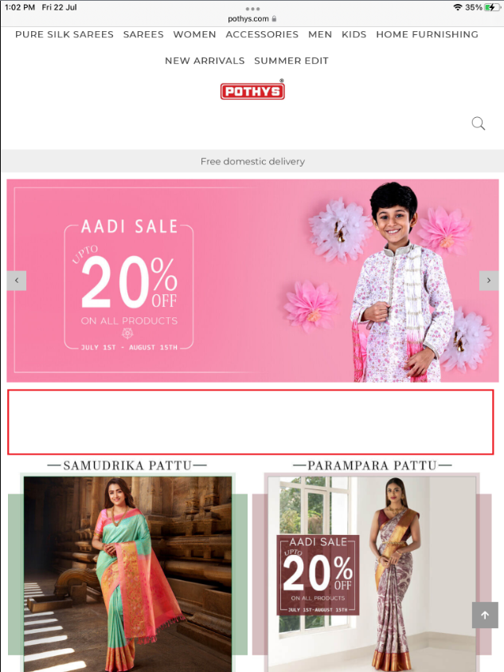

**Fixed:**

**Note: This is the maximum limit to hide unwanted space in home page.**

2, In safari browser, in main category page, vertical space is large in the landscape mode.

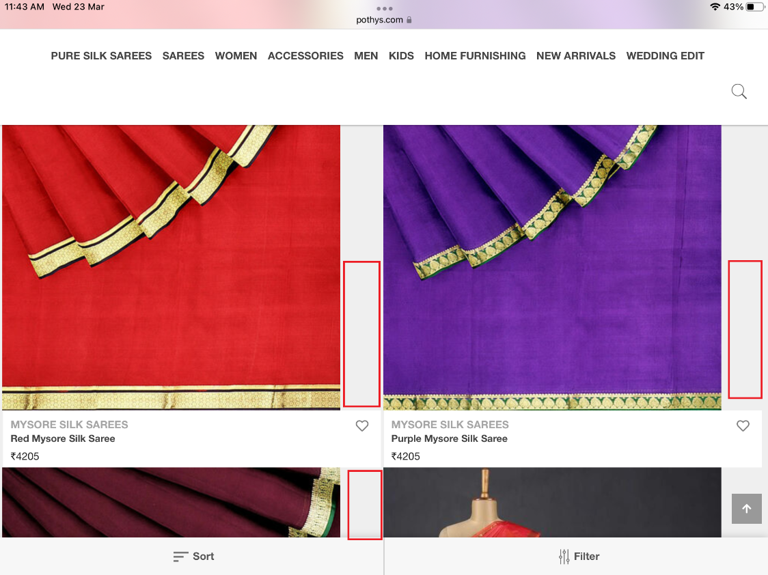

**Fixed:**

